
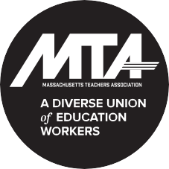

Join fellow MTA members and community supporters from across the metro region in saying…

